1) Calories_consumed-> predict weight gained using calories consumed
2) Delivery_time -> Predict delivery time using sorting time
3) Emp_data -> Build a prediction model for Churn_out_rate
4) Salary_hike -> Build a prediction model for Salary_hike
Do the necessary transformations for input variables for getting better R^2 value for the model prepared.
3) EMP_Data
Data:-
In this employee dataset,10 observation with salary and churn.

EDA:-
Do a exploratory data analysis on both salary and churn of the dataset.

Correlation analysis:-
we analyse correlation or linear relationship between output of column churn with salary.
Correlation for salary vs churn is -0.9117.
so correlation is negative.

Linear Model:-
After analysing correlation technique,we do linear model between output with input Variables .Then we find R-square and Adjusted R-squared value
R-square for salary vs churn :0.8312
Adjusted R-square for salary vs churn :0.8101

RMSE:-
After completes the model,we find Root Mean Square Error.
RMSE value for salary vs churn : 3.99

Transformation Technique:-
Then we doing a transformation technique to find the high R square and adjusted R square values.for that we use lot of transformation techniques(sqrt,log,reciprocal..) Applied with input and outputs.

Sqrt technique with input:-
Correlation analysis:-
we analyse correlation or linear relationship between output of column churn with Square root of salary.
Correlation for churn vs Sqrt(salary) consumed is -0.9165311
so correlation is negative.

Linear Model:-
After analysing correlation technique,we do linear model between output with input Variables .Then we find R-square and Adjusted R-squared value
R-square for sqrt(salary) vs churn : 0.84
Adjusted R-square for sqrt(salary) vs churn :0.82

RMSE:-
After completes the model,we find Root Mean Square Error.
RMSE value for sqrt(salary) vs churn : 3.891995

Log technique with input:-
Correlation analysis:-
we analyse correlation or linear relationship between output of column churn with log of salaries.
Correlation for churn vs log(salary) consumed is -0.92
so correlation is very high.
Linear Model:-
After analysing correlation technique,we do linear model between output with input Variables .Then we find R-square and Adjusted R-squared value
R-square for churn vs log(salary) :0.8486
Adjusted R-square for churn vs log(salary) :0.8297

RMSE:-
After completes the model,we find Root Mean Square Error.
RMSE value for churn vs log(salary) : 3.786

Log technique with input variable with squared output:-
Correlation analysis:-
we analyse correlation or linear relationship between output of column sqrt of churn with log of salary.
Correlation for log(salary)vs(churn*churn) consumed is -0.89
so correlation is negative.

Linear Model:-
After analysing correlation technique,we do linear model between output with input Variables .Then we find R-square and Adjusted R-squared value
R-square for log(salary)vs(churn*churn) :0.9786
Adjusted R-square for log(salary)vs(churn*churn) :0.9725

RMSE:-
After completes the model,we find Root Mean Square Error.
RMSE value for log(salary)vs(churn*churn) : 0.0074

Sqrt technique on output variable:-
Correlation analysis:-
we analyse correlation or linear relationship between output of column weight gain with Square root of Calories consumed.
Correlation for salary vs Sqrt(churn) is -0.92
so correlation is negative.

Linear Model:-
After analysing correlation technique,we do linear model between output with input Variables .Then we find R-square and Adjusted R-squared value
R-square for salary vs Sqrt(churn) : 0.856
Adjusted R-square for salary vs Sqrt(churn) :0.8346

RMSE:-
After completes the model,we find Root Mean Square Error.
RMSE value for salary vs Sqrt(churn) :0 .215

Prediction technique:-
I am get high R-square and Adjusted R-square values in Sqrt technique with output.(i.e.., log(churn) vs sqrt(salary))
I will predict a future answers with these linear models with interval of predict.

Error:-
predicted model then we will applied with fitting a exponential for predicted result
then finding a error associated with these exponential value and output(churn).

RMSE:-
find the error then we applied with RMSE technique to finds the Rmse values
rmse value is 66.19

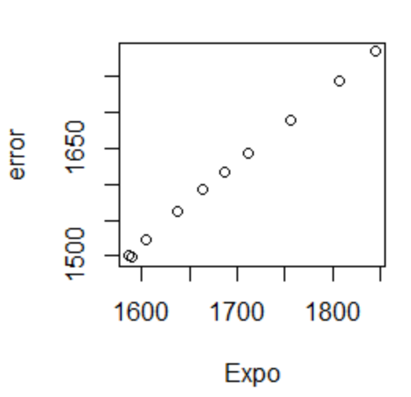
Plotting a graph between Exponential value vs Error:-

R-Code:-
emp<-read.csv(file.choose())
names(emp)[1]="salary" # change column names
names(emp)[2]="churn"
attach(emp)

cor(churn,salary)##-0.9117216
regaa=lm(churn~salary)
summary(regaa)## R-squared: 0.8312, Adjusted R-squared: 0.8101
sqrt(sum(regaa$residuals^2)/nrow(emp))# 3.997528

#output::Churn input::salary

#input with sqrt
cor(churn,sqrt(salary))##-0.9165311(Negative correlation)
regbb=lm(churn~sqrt(salary))
summary(regbb)##R-squared: 0.84, Adjusted R-squared: 0.82
sqrt(sum(regbb$residuals^2)/nrow(emp))#3.891995

#input with log
cor(churn,log(salary))##-0.9212077(Negative correlation)
regcc=lm(churn~log(salary))
summary(regcc)## R-squared: 0.8486, Adjusted R-squared: 0.8297
sqrt(sum(regcc$residuals^2)/nrow(emp))#3.786

#output on sqrt with input on log
cor(log(salary),churn*churn)## -0.8965286(Negative correlation)
regdd=lm(log(salary)~churn+I(churn*churn))
summary(regdd)## R-squared: 0.9786, Adjusted R-squared: 0.9725
sqrt(sum(regdd$residuals^2)/nrow(emp))#0.0074
########## Prediction for Better R values ########
predg=as.data.frame(predict(regdd,interval = "predict"))
Expo=exp(predg$fit)
error=Expo-churn
sqrt(sum(err^2)/nrow(emp))# 66.19578
plot(Expo,error)

###output Variable sqrt
cor(salary,sqrt(churn))##-0.9235755(Negative correlation)
regee=lm(sqrt(churn)~salary)
summary(regee)##R-squared:0.853, Adjusted R-squared: 0.8346
sqrt(sum(regee$residuals^2)/nrow(emp))#0.215

###output Variable log
cor(salary,log(churn))#-0.934(Negative correlation)
regff=lm(log(churn)~salary)
summary(regff)# R-squared: 0.8735, Adjusted R-squared: 0.8577
sqrt(sum(regff$residuals^2)/nrow(emp))#0.04

